
Microsoft Bookings
Ms. Alyssa Tortora

How to access
-Log in to email
-Go to waffle on the side where you log in to Onedrive and click on bookings. (If you do not see it clock “All Apps.”
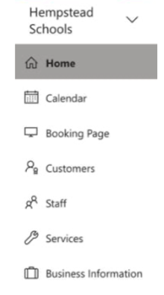
-When you open up Microsoft bookings you will see tabs on the right side that say: Home, Calendar, Bookings Page, Customers, Staff, Services, Business Information

Work Backwards
Business information:
-Enter business information- Name, address, phone number, email
-Change the picture if you would like
-Enter business hours

Services
- + Add a Service
- Service name-Parent Teacher Conferences
- Description- 10 minute conference about your child’s progress.
- Default location- (Do not change anything keep it off.)
- Duration- 10 minutes
- Attendees- 1
- Price (N/A)
- Custom fields; Modify (customer email, phone number, address, customer notes)At the top you can add a text question.
I would suggest not making any of the listed fields mandatory, unless you would like. But I would add a question asking for the child’s name.
-Reminders and Confirmation- (1 day). Can add email reminder and any additional information for email confirmation. Can also enable text message notifications (they have to put in their phone number for this)
-Publishing options (check)
-Online scheduling options (uncheck)
-Scheduling policy- Time increments (10 min)
-Staff – (you do not need to add any staff)
-Email notifications: Both checked if wish.
-Availability- General (not bookable), Availability during these dates 2/10-2/10, Hours 1:00-4:00 PM and 6:00-8:00 PM, not bookable on other days.
-Click Save

Staff – you do not need to add any staff

Customers- They will appear once you have customers.

Booking page:
-Publish to receive the link.
-Booking page access control: Check “Disable direct search engine indexing of booking page.
-Scheduling policy: Time increments
-Email notifications
-Staff
-Availability- Bookable when staff are free
-Customize your page: You can customize the theme.
-Save and publish

Calendar
Can view your calendar, make a new booking.
Home

Send the link out to parents and have them start booking!
Once parents book you will receive an email about the time they booked.

